CT-2000PRO/PRO-i/PLUS
Special Model for Textile/Spinning Industry.
Characteristic
Output frequency 0.5~240.0Hz
External analog setting 0~10V and 4~20mA
Automatic torque compensation and slip compensation
PWN frequency 1.5~10KHz
10 pattern and any V/F pattern
Built-in PI control
Built-in standard RS422/485 communication port, MODBUS RTU protocol
8-step speed setting
Frequency increase/decrease（UP / DOWN）function and 16-step function control setting
Restart / Free run start
Operation interface (LCD & LED dual display for Pro, LED display for Plus)
2-step acceleration/deceleration
Built-in specialized functions for textile industry
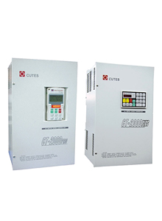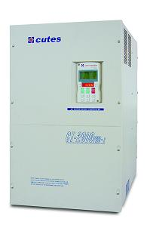
Standard Specification
A. CT2000Plus 200V Series
Motor rating (KW) | 2.2 | 3.7 | 5.5 | 7.5 | 11 | 15 | 22 | 30 | 37 | 45 | 55 | 75 | 93
Model  CT2000Plus- | 2A2 | 3A7 | 5A5 | 7A5 | 011 | 015 | 022 | 030 | 037 | 045 | 055 | 075 | 093
Rated current (A) | 11.1 | 18 | 23 | 33 | 48 | 61 | 86 | 125 | 150 | 170 | 210 | 278 | 330
Rated capacity (KVA) | 4.4 | 7.1 | 9.2 | 13.1 | 19.1 | 24.3 | 34.3 | 49 | 60 | 68 | 84 | 111 | 131
Power supply | 3∮ 200~230V ±10% 50HZ/60Hz ±5%
Output voltage | 3∮ 200V、220V、230V
Cooling system | Forced air-cooling
Weight (Kg) | 8 | 8 | 9 | 14 | 14 | 22 | 23 | 46 | 49 | 50 | 75 | 83 | 89
B. CT2000Plus 400V Series
Motor rating (KW) | 2.2 | 3.7 | 5.5 | 7.5 | 11 | 15 | 22 | 25 | 30 | 37 | 45 | 55 | 75 | 93 | 112
Model  CT2000Plus- | 2A2 | 3A7 | 5A5 | 7A5 | 011 | 015 | 022 | 025 | 030 | 037 | 045 | 055 | 075 | 093 | 112
Rated current (A) | 6.2 | 9 | 13 | 17.3 | 24 | 31 | 52 | 61 | 65 | 71 | 93 | 110 | 156 | 180 | 225
Rated capacity (KVA) | 4.9 | 7.1 | 10.4 | 13.8 | 19.1 | 24.7 | 41.4 | 47.1 | 51.8 | 56.6 | 74 | 87.6 | 124 | 143 | 180
Power supply | 3∮ 380~460V ±10% 50HZ/60Hz ±5%
Output voltage | 3∮ 380V、400V、415V、440V、460V
Cooling system | Forced air-cooling
Weight (Kg) | 8 | 8 | 9 | 15 | 15 | 17 | 25 | 25 | 26 | 49 | 51 | 53 | 79 | 82 | 91



